2023 Birthday Book Club

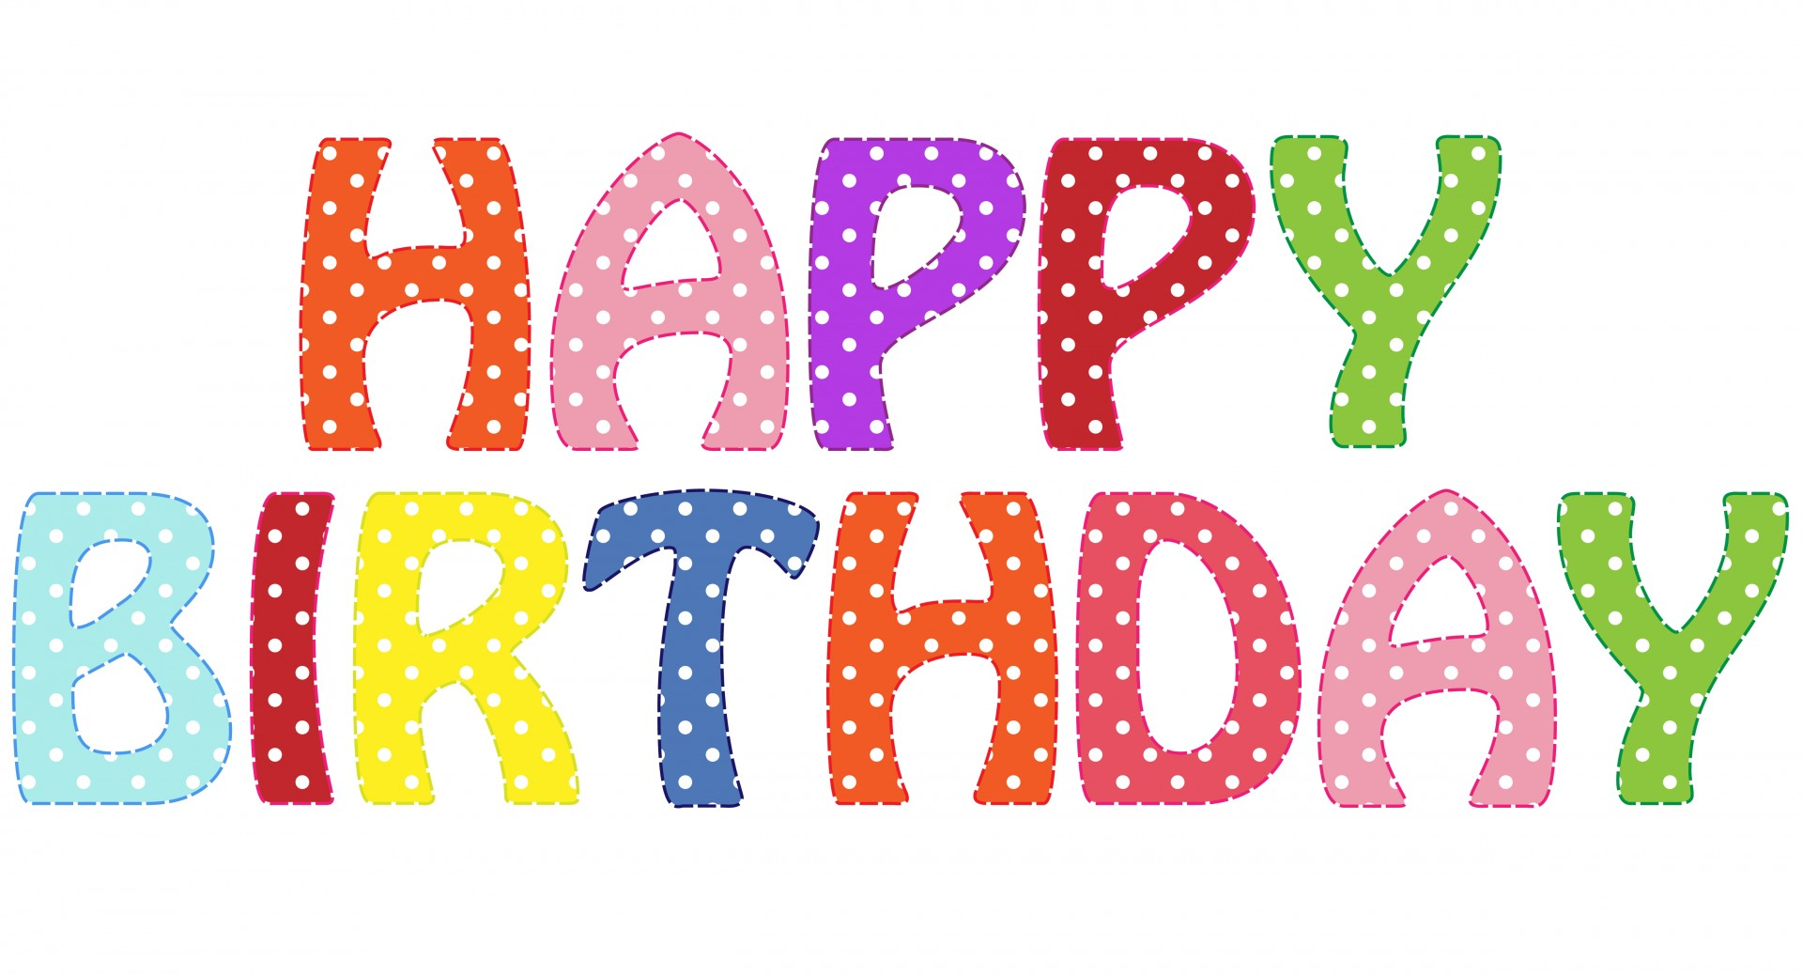

We would like to invite you to sign your student(s) up for Ogletree Birthday Book Club. This is one way the library purchases new books. We will have one in September celebrating June-November birthdays, and one in January celebrating December-May birthdays. If a student misses the September party, anyone is welcome to join the January club even if their birthday doesn’t fall between those dates.

**The cost is $15, and is payable by check, cash, or MySchoolBucks.**

**The deadline to sign up for the fall party is Friday, September 15**.

Participants will choose a brand new hardback book which will have their name inside, and it will need to be returned to the library after two weeks. On the date of the party, they will meet in the commons area for:

* Games and MANY door prizes
* A magnificent magic show by our very own Mr. Hooks
* A sweet treat before leaving

Thank you for supporting our OES library program!

Mrs. Audrey Barker, NBCT

Librarian/Tech Coordinator

Student Name_______________________________Teacher___________________________

My child’s birthday is between: ____ June-November or ____December-May

Parent Phone Number_________________________

_____ I have paid on MySchoolBucks _____I am paying check/cash